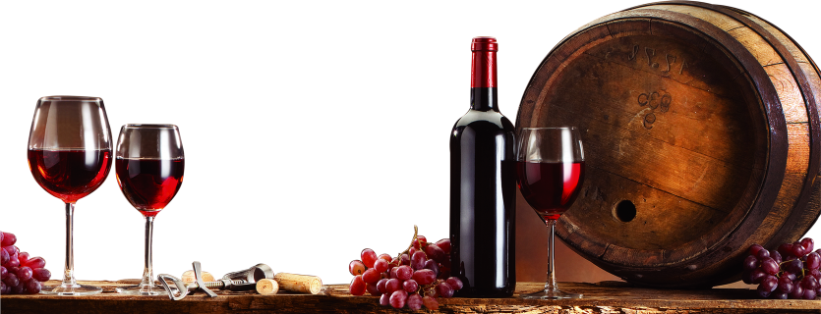

**Winery and a micro-Brewery:**

**High Level Customer Use case and System Design**

**Content**

1. Executive overview of the system 3

1.1 Background 3

1.2 Pain Points - Manager requirement/ problems need to solve 3

2. Actionable Insights - Business Users draw from the system 4

3. Flowchart Flow of System 6

4. Key Entities in the System 7

5. Entity-Relational (ER) Model 8

6. SQL Queries with Actionable Insights 9

7. #3 detailed SQL procedures 12

8. Appendix: 17

8.1 Create Table scripts 17

8.2 References 18.

# A picture containing alcohol Description automatically generated1. Executive overview of the system

## **1.1 Background**

We are working for a winery and microbrewery producing all sorts of wine and brew, including red, white, sparkling, rose, dessert, fortified, large, ale, etc. The company has its planting grounds and responsible for the entire production process from harvesting to packaging. The company uses spreadsheets to store the past 21 years of information and has presently chosen to change to a Database management system to improve operational working process.

## **1.2 Pain Points - Manager requirement/ problems need to solve**

***#1 Pain Point: Products Consulting***

The Sales Manager thinks that it takes a lot of time for employees to review product information when consumers want to consult all product details on the phone. It is low efficiency and practical to search the table to obtain related product details and also to impact the customer's purchasing experience.

***#2 Pain Point: Customer Preferences***

In the new year, the Sales & Marketing Manager wants to decide on a better marketing strategy. He wants to aware of the customer preferences by finding the most popular wine and beer, and he also wants to know the total sales of different countries.

***#3 Pain Point: Employees Performance***

Our company wants to reward workers every year in order to motivate our employees. The Financial Manager has difficulty figuring out a more productive way to measure the bonus and the highest-selling performance employees.

***#4 Pain Point: Calculate Sales Tax***

The Financial Manager is having trouble updating and calculating the sales tax in different years. He always makes mistakes in his manual calculation on spreadsheets, which takes him a lot of time to check repeatedly to find the errors. He is asking if there is a better way to finish the work.

***#5 Pain Point: Products that did not sold***

Some wines did not have buyers to purchase. The Winery Department Manager has a problem counting the lousy selling products and decides the next step on dealing with these products.

***#6 Pain Point: Promotion Opportunities***

Our company wants to provide more opportunities to young employees. Therefore, they wonder if we can find out the youngest employees in each.

***#7 Pain Point: Mistakes on the spelling of the country***

When the Sales Manager checks on the selling of all countries, he finds out there are some mistakes in spelling of the countries. He is asking to get a convenient method to solve the problem of misspelling.

***#8 Pain Point: Empty cells to NULL***

When Sales looking for customer information in customer table, they have found out there are some of the empty cells are not marked as NULL. Therefore, Sales department want a procedure to could change the empty cells to NULL by only entering table name and column name.

# Actionable Insights - Business Users draw from the system

***For #1 Pain Point: Products Consulting***

1. Improve the working efficiency and precise information of the wine.

Employees can enter the related keywords to get all the required information of the wine and beer, including grapes name, alcohol percentage, capacity, inventory, and price when the customers consulting through the phone or email, which can help to engage the efficiency on replying the email or asking on the phone either, and improving the purchasing experience of customers at the same time.

***For #2 Pain Point: Customer Preferences***

1. Help to determine grapes harvesting and production.

By creating a report on the most popular wine and beer every year, the Winery Department can decide which grapes should increase or reduce production based on selling and customer preferences.

1. Help to build a better Marketing and Advertising Plan.

In addition, the Sales & Marketing team can also decide on a better promotion and marketing strategy based on the selling of each countries, to determine the budget of advertising in different countries.

***For #3 Pain Point: Employee Performance***

1. By creating a procedure to calculate selling team's bonus with certain percentage and finding out the best employees on selling performance, the company can reward the relative commission based on their selling performance and award the best-performing employee. This can push and engage employees to work hard on selling products and encourage their hard work every year.

***For #4 Pain Point: Calculate Sales Taxes***

1. By designing a procedure that will allow the financial manager to work effectively on the sales tax in all countries instead of working on the spreadsheet beforehand. He only needs to type the year and relative sales tax percentage on the formulate procedure, the calculation of sales tax would accurately do for you automatically. It also helps to reduce mistakes.

***For #5 Pain Point: Products that did not sold***

1. After finding out the wine did not sale, the manager can trash these products which store on inventory for a long time. It also helps for considering production of grapes and expands the inventory space to keep the good selling wine and beer.

***For #6 Pain Point: Promotion Opportunities***

1. The company is shifting it’s confuses on young employees as the company is targeting a more trendy for market promoting. Therefore, the company is considering more promotion opportunities to the younger generation. Getting the information of all youngest employees in different departments help the higher-level manager to make decision as they referencing info from the table.

***For #7 Pain Point: Spelling Mistakes of Countries***

1. Manual data entry is easy to produce typo within the spreadsheet or database. Therefore, a procedure is created for the manager to correct the typo more easily when checking on the most popular wine of all the countries.

***For #8 Pain Point: Spelling Mistakes of Countries***

1. By showing NULL can give a more clear concept for employees which is absence of value instead of string value of zero length.

# Flowchart Flow of System

# Key Entities in the System



# Entity-Relational (ER) Model



# SQL Queries with Actionable Insights

1. **Customer Preferences:**

Help to determine grapes harvesting and production by creating a report on the most popular wine and beer every year and decide the advertising budget based on the total sales of each country.

*# Pain point 2 - Most popular product per type*

*SELECT COUNT(OD.PRODUCT_ID), P.PRODUCT_NAME, P.PRODUCT_TYPE*

*FROM ORDER_DETAILS AS OD, PRODUCT AS P*

*WHERE OD.PRODUCT_ID = P.PRODUCT_ID*

*GROUP BY P.PRODUCT_TYPE, P.PRODUCT_NAME*

*ORDER BY COUNT(OD.PRODUCT_ID) DESC;*

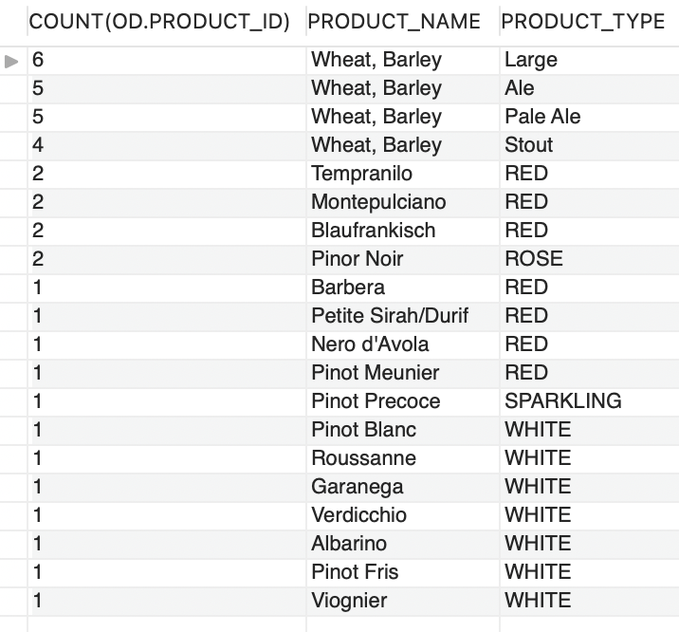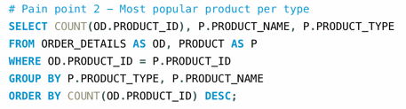

*# Pain point 2 - The amount of order per country*

*SELECT SUM(S.PRICE) AS "Sales number", C.COUNTRY*

*FROM SALES AS S, CUSTOMER AS C*

*WHERE S.CUS_ID = C.CUS_ID*

*GROUP BY C.COUNTRY*

*ORDER BY SUM(S.PRICE)DESC;*

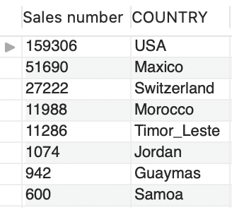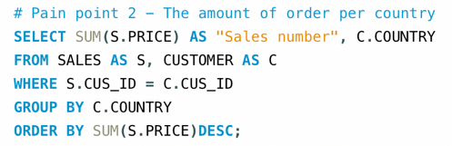

1. **Bad-selling Products:**

Finding out product that did not sold.

*# Pain point 5 - Product that did not sold*

*SELECT P.PRODUCT_ID, P.PRODUCT_NAME*

*FROM PRODUCT AS P*

*WHERE P.PRODUCT_ID NOT IN (SELECT DISTINCT OD.PRODUCT_ID FROM ORDER_DETAILS AS OD);*

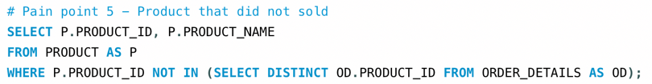

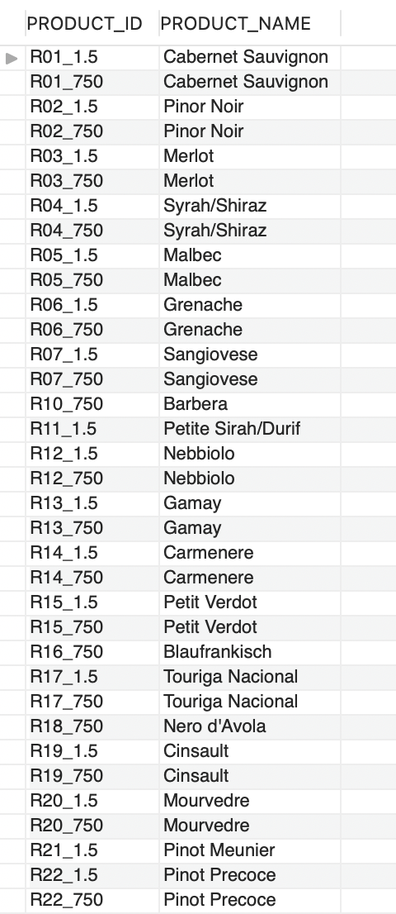

1. **Promoted Opportunities:**

Find out the youngest employees in each.

*# Pain point 6 - Promoted opportunities*

*SELECT DISTINCT E.EMP_ID, P.DEPT_NAME, CONCAT_WS(', ', E.LAST_NAME,E.FIRST_NAME) AS "FULL NAME", E.BDAY*

*FROM EMPLOYEES AS E, EMP_POSITION AS EP, POSITION AS P*

*WHERE E.EMP_ID = EP.EMP_ID*

*AND P.POSITION_ID = EP.POSITION_ID*

*AND E.BDAY IN (SELECT MAX(BDAY)*

*FROM EMPLOYEES AS E, EMP_POSITION AS EP, POSITION AS P*

*WHERE E.EMP_ID = EP.EMP_ID*

*AND P.POSITION_ID = EP.POSITION_ID*

*AND EP.POSITION_END_DATE > CURDATE()*

*GROUP BY P.DEPT_NAME);*

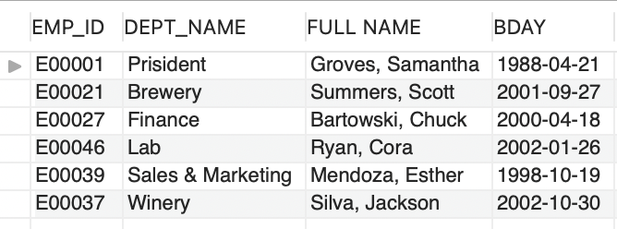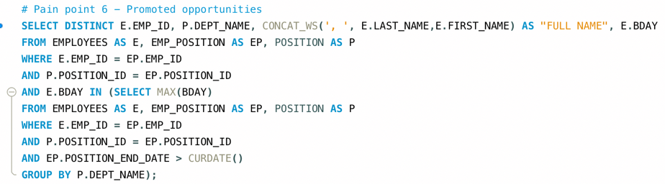

# #4 detailed SQL procedures

# #1 - Products Consulting

* Procedure Name: product_consult
* Objective: Improve the working efficiency and precise information of the wine
* Input: product_id
* Output: Including product name, type, alcohol percentage, capacity, inventory, and price
* Procedure SQL Code:

*CREATE DEFINER=`root`@`localhost` PROCEDURE `product_consult`(IN in_product_id VARCHAR(7))*

*BEGIN*

*SELECT DISTINCT P.*, IF(I.OUT_DATE>CURDATE(),"Y","N") AS "Stock Available"*

*FROM PRODUCT AS P, PRODUCT_PROCESS AS PD, INVENTORY AS I*

*WHERE P.PRODUCT_ID = PD.PRODUCT_ID*

*AND PD.LOT_NO = I.LOT_NO*

*AND P.PRODUCT_ID = in_product_id;*

*END*

* Three Test Conditions and Results:

*# Pain point 1 - Product consult (Create Procedure)*

*SELECT DISTINCT P.*, IF(I.OUT_DATE>CURDATE(),"Y","N") AS "Stock Available"*

*FROM PRODUCT AS P, PRODUCT_PROCESS AS PD, INVENTORY AS I*

*WHERE P.PRODUCT_ID = PD.PRODUCT_ID*

*AND PD.LOT_NO = I.LOT_NO*

*AND P.PRODUCT_ID = "L01_355";*

*call product_consult("L01_355");*

*call product_consult("R18_1.5");*

*call product_consult("A01_650");*







**#2 - Employee Performance**

* Procedure Name: *commission_calculation*
* Objective: Calculate the commission for sales team every year
* Input: order_year, commission_rate
* Output: The commission amount of the employees
* Procedure SQL Code:

*CREATE DEFINER=`root`@`localhost` PROCEDURE `commission_calculation`(IN in_order_year INT, IN in_commission_rate DECIMAL(4,3))*

*BEGIN*

*SELECT EMP_ID, SUM(PRICE) AS "EMPLOYEE REVENUE", (SUM(PRICE)*in_commission_rate) AS "COMMISSION AMOUNT"*

*FROM winery_micro_brewery.ORDER AS OD, SALES AS S*

*WHERE OD.ORDER_ID = S.ORDER_ID*

*AND YEAR(OD.ORDER_DATE) = in_order_year*

*GROUP BY S.EMP_ID;*

*END*

* Three Test Conditions and Results:

*# Pain point 3 - COMMISSION (Create procedure)*

*SELECT EMP_ID, SUM(PRICE) AS "EMPLOYEE REVENUE", (SUM(PRICE)*0.01) AS "COMMISSION AMOUNT"*

*FROM winery_micro_brewery.ORDER AS OD, SALES AS S*

*WHERE OD.ORDER_ID = S.ORDER_ID*

*AND YEAR(OD.SHIP_DATE) = 2011*

*GROUP BY S.EMP_ID;*

*call commission_calculation(2011,0.01);*

*call commission_calculation(2013,0.05);*

*call commission_calculation(2015,0.10);*

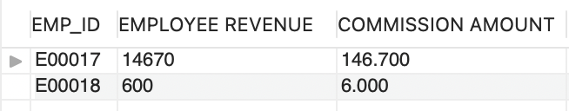

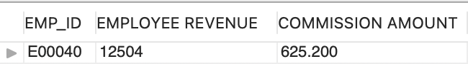

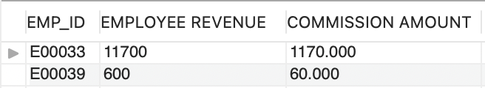

**#3 – Sales Taxes**

* Procedure Name: tax_calculation
* Objective: Calculate precise taxes for every year
* Input: year, tax_rate
* Output: Sales taxes of year
* Procedure SQL Code:

*CREATE DEFINER=`root`@`localhost` PROCEDURE `tax_calculation`(IN in_year INT, IN in_tax_rate DECIMAL(4,3))*

*BEGIN*

*SELECT SUM(PRICE) AS "THIS YEAR REVENUE", (SUM(PRICE)*in_tax_rate) AS "TAX AMOUNT"*

*FROM winery_micro_brewery.ORDER AS OD, SALES AS S*

*WHERE OD.ORDER_ID = S.ORDER_ID*

*AND YEAR(OD.SHIP_DATE) = in_year;*

*END*

* Three Test Conditions and Results:

*# Pain point 4 - TAX (Created procedure)*

*SELECT SUM(PRICE) AS "THIS YEAR REVENUE", (SUM(PRICE)*0.01) AS "TAX AMOUNT"*

*FROM winery_micro_brewery.ORDER AS OD, SALES AS S*

*WHERE OD.ORDER_ID = S.ORDER_ID*

*AND YEAR(OD.SHIP_DATE) = 2011;*

*call tax_calculation(2011,0.01);*

*call tax_calculation(2013,0.05);*

*call tax_calculation(2015,0.10);*

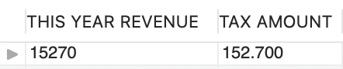

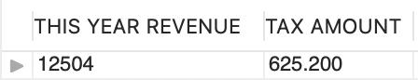

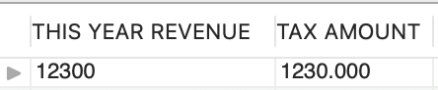

**# 4 – Spelling Mistakes of Countries**

* Procedure Name: spelling_correction
* Objective: Correct the mistakes of countries’ spelling
* Input: incorrect_spelling, correct_spelling
* Output:
* Procedure SQL Code:

*CREATE DEFINER=`root`@`localhost` PROCEDURE `spelling_correction`(IN in_incorrect_spelling VARCHAR(50), IN in_correct_spelling VARCHAR(50))*

*BEGIN*

*DECLARE done INT DEFAULT FALSE;*

*DECLARE c VARCHAR(100);*

*DECLARE cur1 CURSOR FOR*

*SELECT COUNTRY FROM CUSTOMER;*

*DECLARE CONTINUE HANDLER FOR NOT FOUND SET done = TRUE;*

*OPEN cur1;*

*read_loop: LOOP*

*FETCH cur1 into c;*

*IF done THEN*

*LEAVE read_loop;*

*END IF;*

*IF c = in_incorrect_spelling THEN*

*UPDATE CUSTOMER*

*SET COUNTRY = in_correct_spelling*

*WHERE COUNTRY = c;*

*END IF;*

*END LOOP;*

*END*

* Three Test Conditions and Results:

*# Pain Point 7 - Correct mispelling in country list in customer table*

*call spelling_correction("Maxico","Mexico");*

*call spelling_correction("Timor_Leste","Timor Leste");*

*call spelling_correction("USS","USA");*

*SELECT COUNTRY FROM CUSTOMER WHERE COUNTRY = "Mexico";*

*SELECT COUNTRY FROM CUSTOMER WHERE COUNTRY = "Timor Leste";*

*SELECT COUNTRY FROM CUSTOMER WHERE COUNTRY = "USA";*

**# 4 – Empty cells to Null**

* Procedure Name: empty_null
* Objective: Change empty cell to NULL datatype
* Input: in_tbl_name, in_col_name
* Output: Change empty cell to NULL datatype
* Procedure SQL Code:

*CREATE DEFINER=`root`@`localhost` PROCEDURE `empty_null`(IN in_tbl_name VARCHAR(50), IN in_col_name VARCHAR(50))*

*BEGIN*

*SET @s=CONCAT("UPDATE ",in_tbl_name," SET ",in_col_name," = NULL WHERE ",in_col_name," = ''");*

*PREPARE stmt from @s;*

*EXECUTE stmt;*

*DEALLOCATE PREPARE stmt;*

*END*

* Three Test Conditions and Results:

*# Pain Point 8 - Empty cells to NULL*

*call empty_null('CUSTOMER', 'CITY');*

*call empty_null('CUSTOMER', 'STATE');*

*call empty_null('CUSTOMER', 'POSTAL_CODE');*

*SELECT * FROM CUSTOMER;*

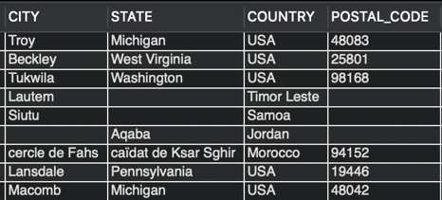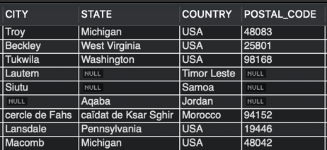

# ****8. Appendix****

## **Text Description automatically generatedText, letter Description automatically generated8.1 Create Table scripts** **& Data loading scripts**

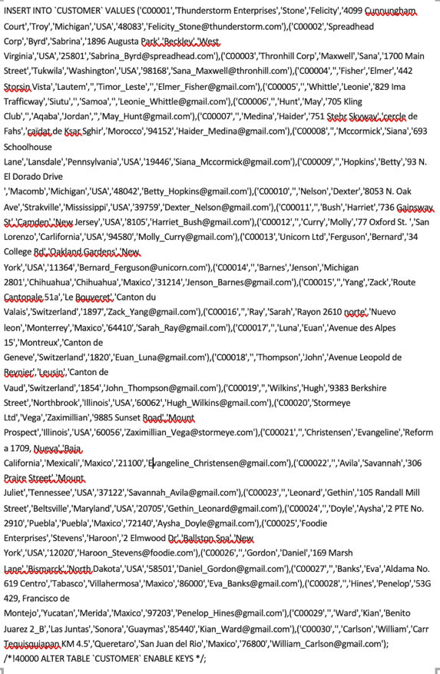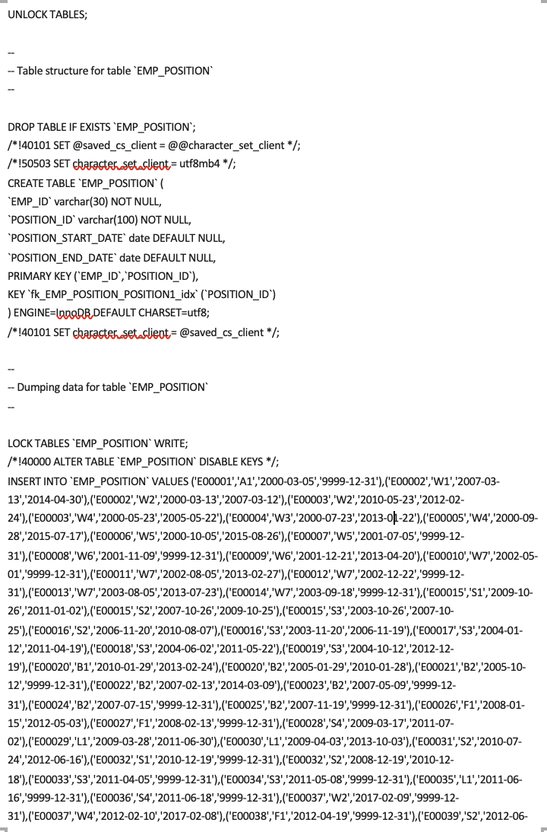

**

**

**

**8.2 Reference**

* <https://aslanbrewing.com/thebrewingprocess>
* https://www.winemonthclub.com/the-wine-making-process

## 